28. create a function for library information system to count the no.of days left to return the books two tables personal information and book information

-- Create the person table

CREATE TABLE person (

person_id NUMBER PRIMARY KEY,

name VARCHAR2(100),

email VARCHAR2(100)

);

/

-- Create the book table

CREATE TABLE book (

book_id NUMBER PRIMARY KEY,

title VARCHAR2(200),

author VARCHAR2(100),

due_date DATE,

person_id NUMBER,

CONSTRAINT fk_person

FOREIGN KEY (person_id)

REFERENCES person(person_id)

);

/

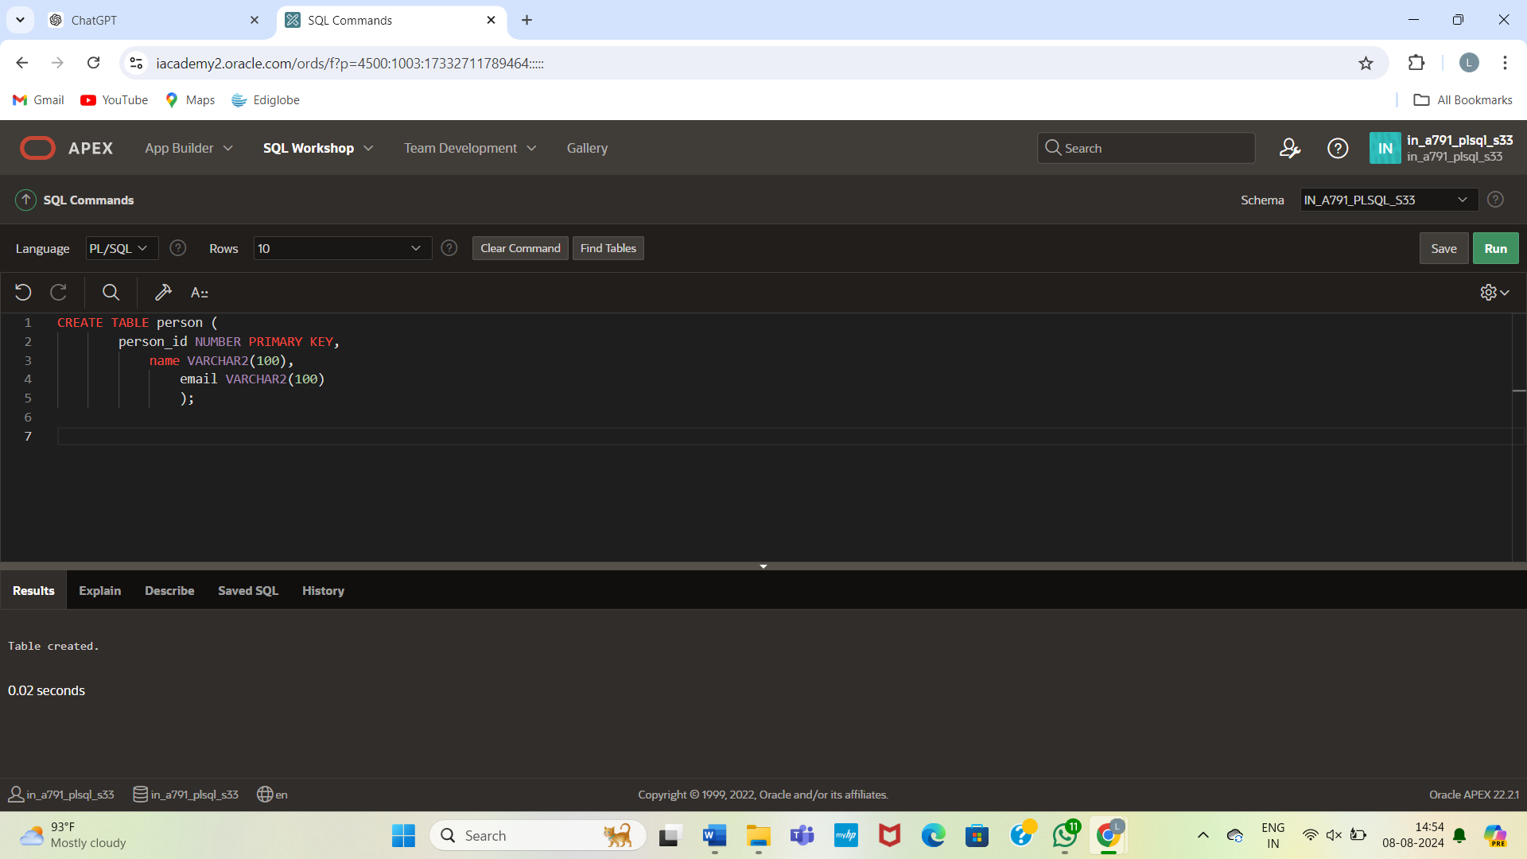

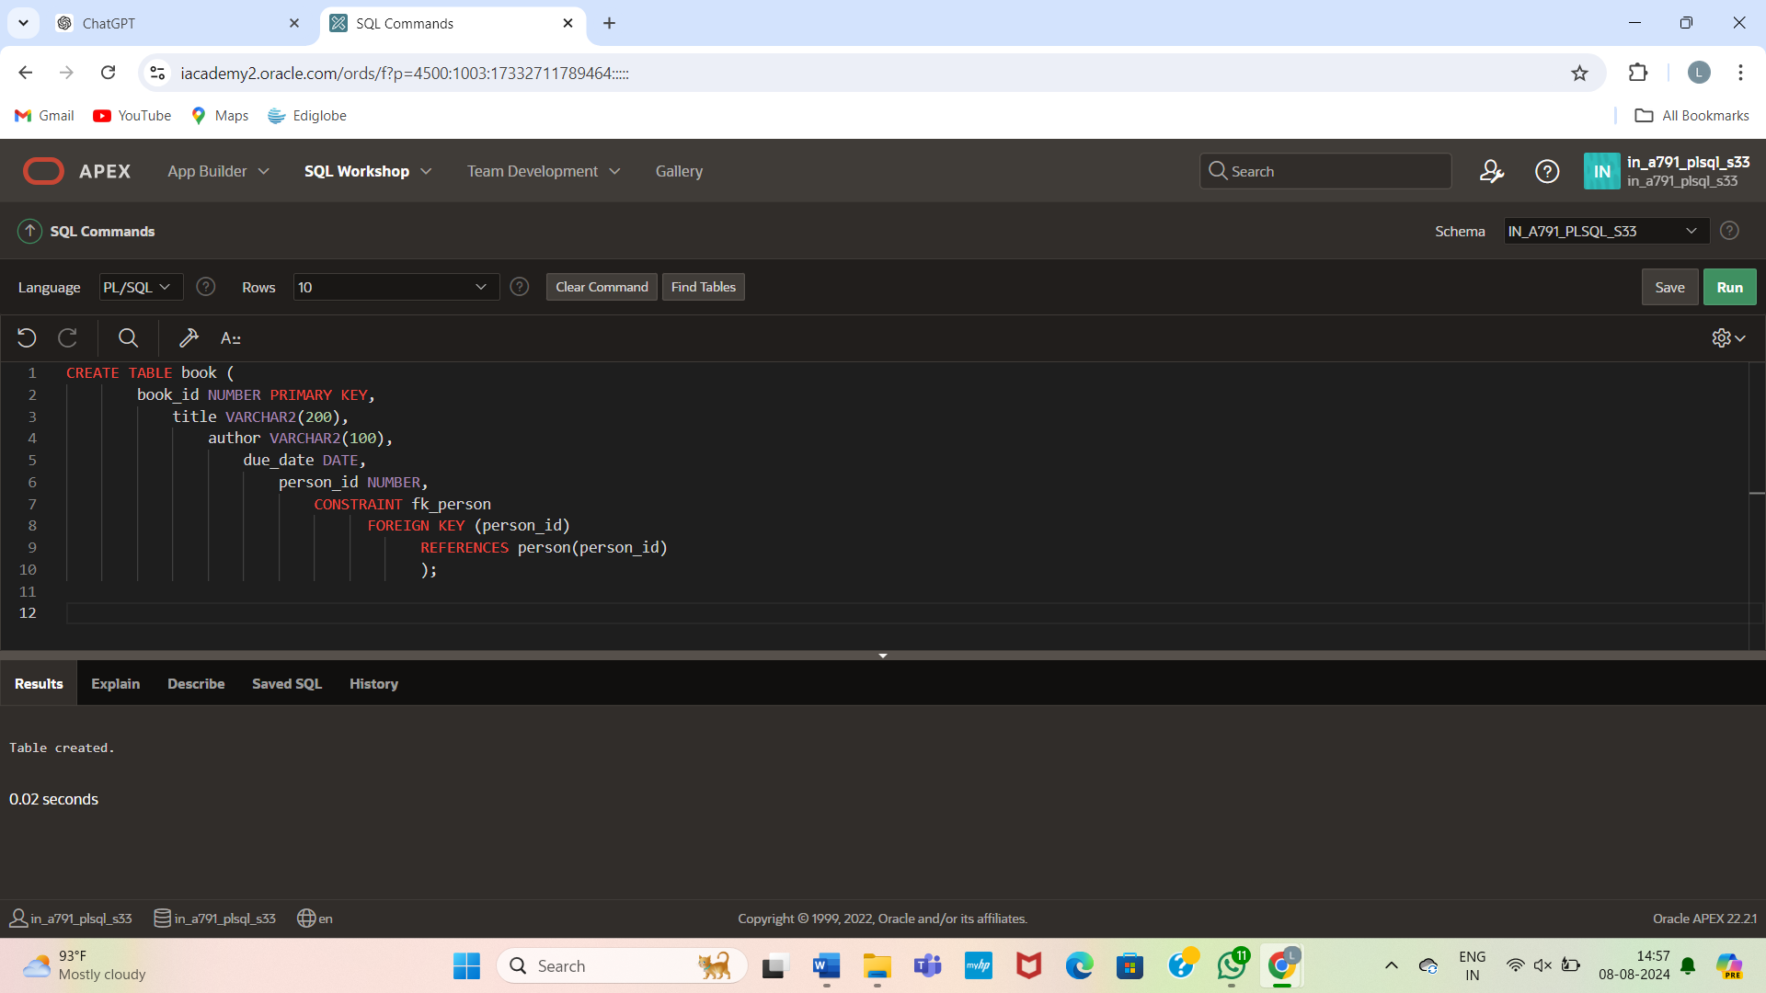

Insert sample data:

-- Insert sample data into person table

INSERT INTO person (person_id, name, email) VALUES (1, 'John Doe', 'john.doe@example.com');

INSERT INTO person (person_id, name, email) VALUES (2, 'Jane Smith', 'jane.smith@example.com');

-- Insert sample data into book table

INSERT INTO book (book_id, title, author, due_date, person_id)

VALUES (1, 'The Great Gatsby', 'F. Scott Fitzgerald', TO_DATE('2024-08-15', 'YYYY-MM-DD'), 1);

INSERT INTO book (book_id, title, author, due_date, person_id)

VALUES (2, 'To Kill a Mockingbird', 'Harper Lee', TO_DATE('2024-08-20', 'YYYY-MM-DD'), 2);

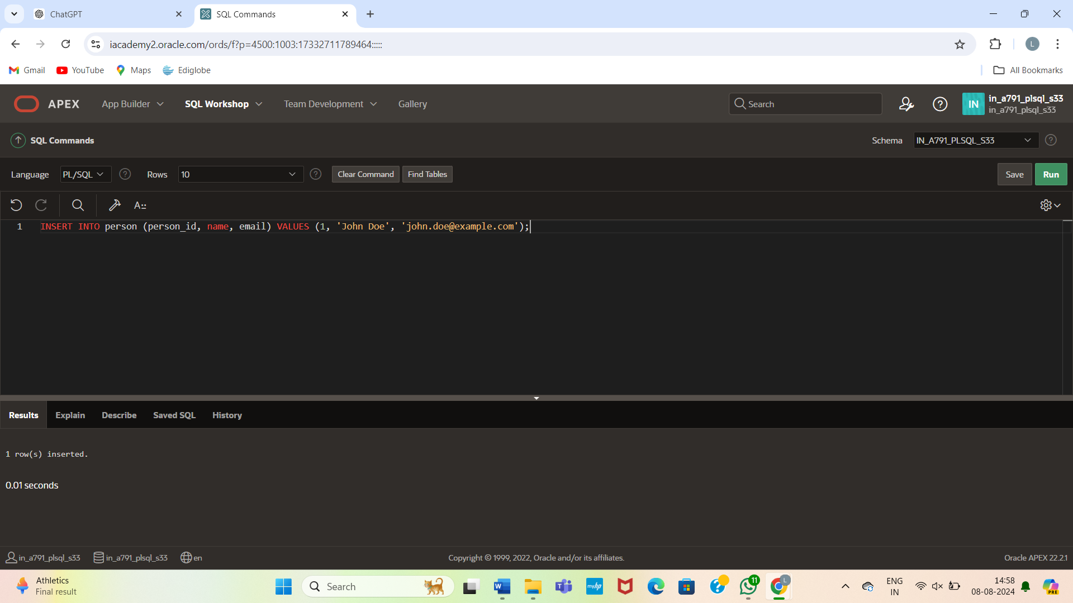

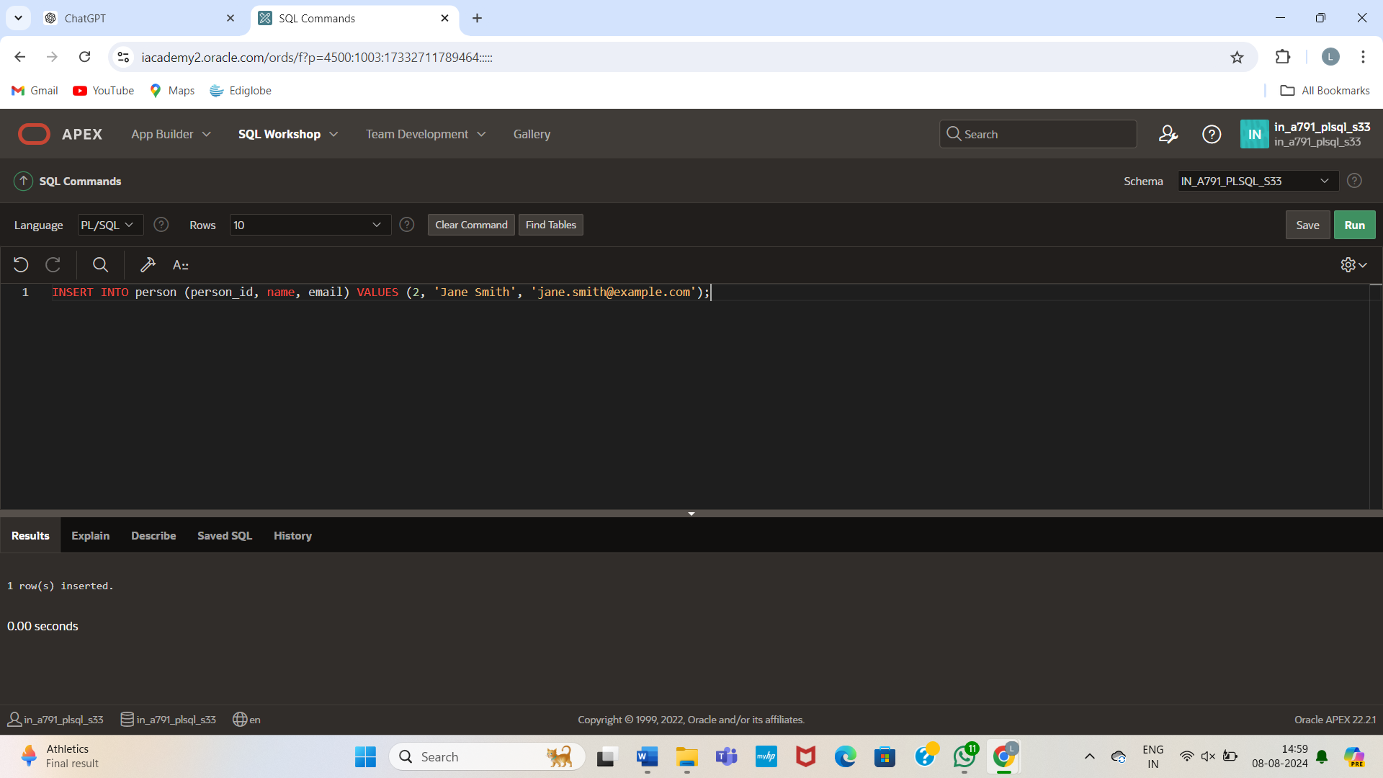

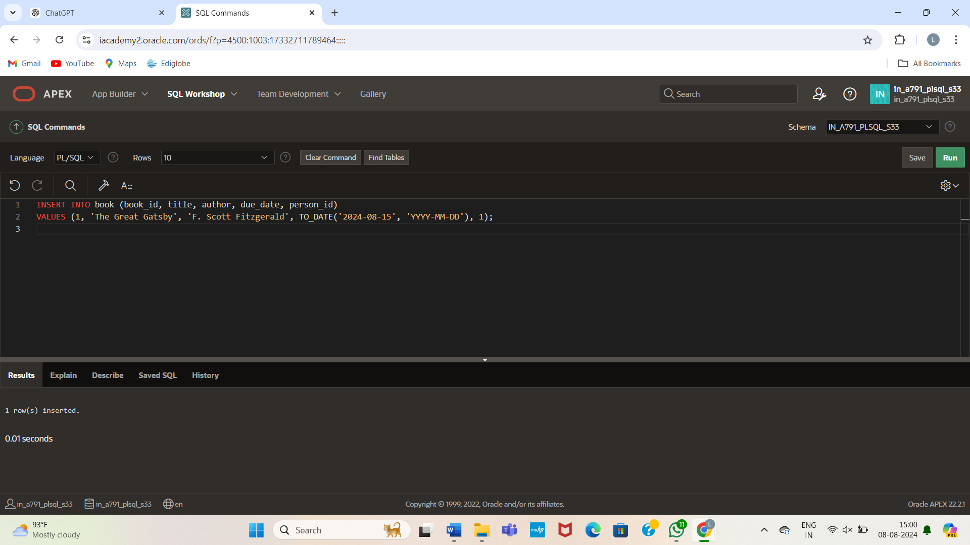

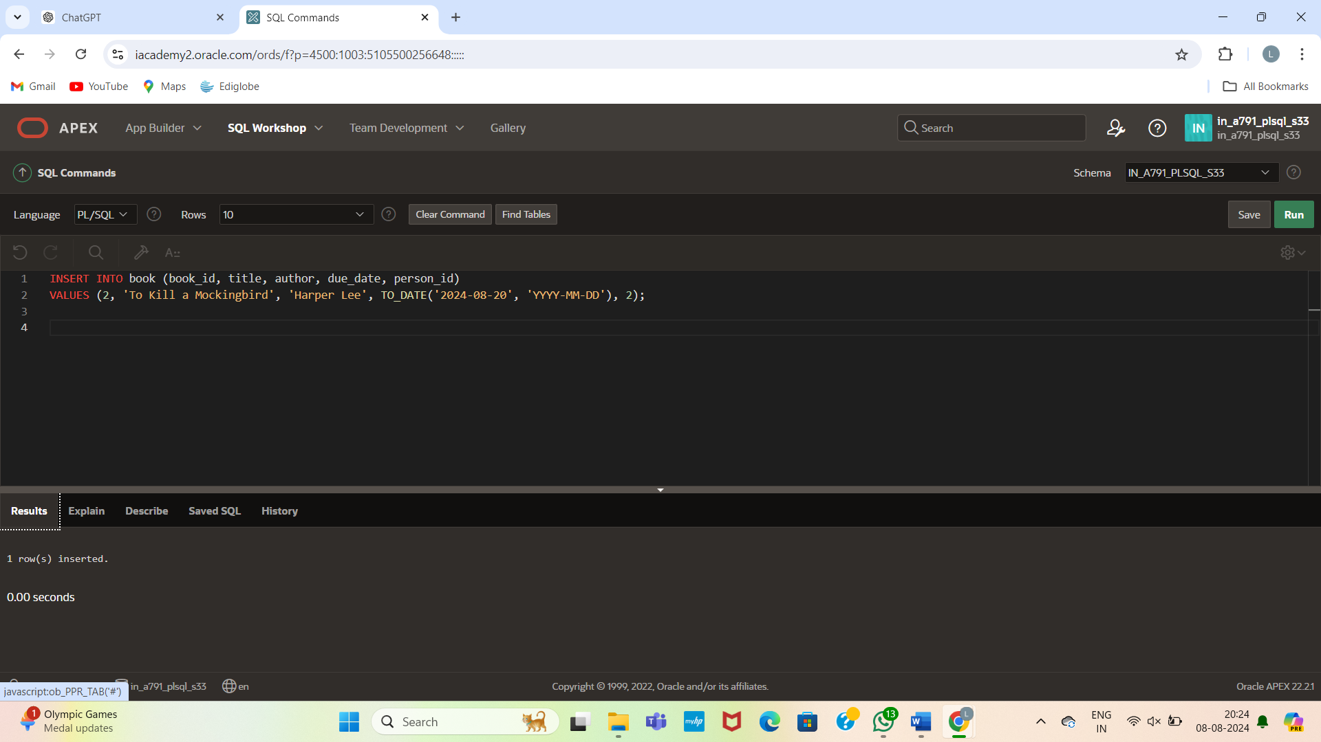

CREATE OR REPLACE FUNCTION days_left_to_return(p_person_id NUMBER, p_book_id NUMBER)

RETURN NUMBER

IS

v_due_date DATE;

v_days_left NUMBER;

BEGIN

-- Get the due date of the book for the given person

SELECT due_date INTO v_due_date

FROM book

WHERE person_id = p_person_id

AND book_id = p_book_id;

-- Calculate the number of days left

v_days_left := v_due_date - SYSDATE;

RETURN v_days_left;

EXCEPTION

WHEN NO_DATA_FOUND THEN

RETURN NULL;

END;

/

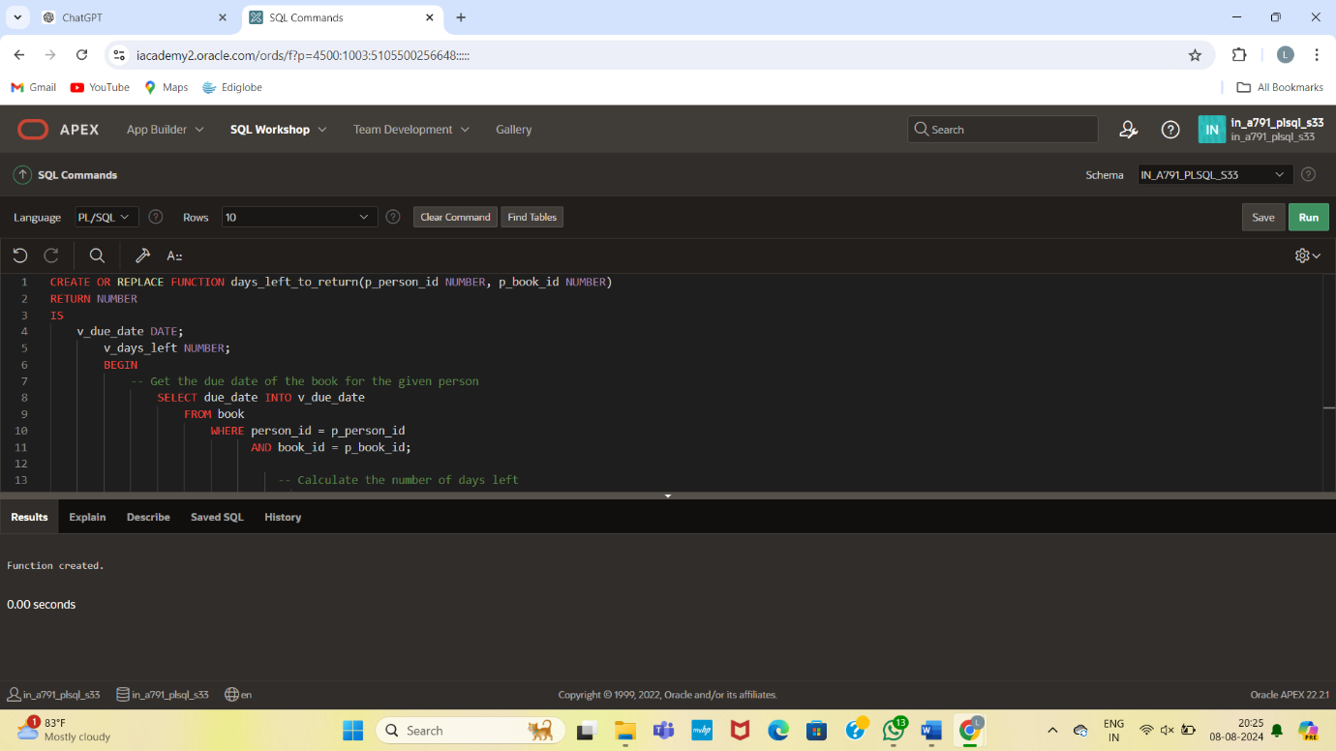

-- Test the function for person_id 1 and book_id 1

DECLARE

v_days_left NUMBER;

BEGIN

v_days_left := days_left_to_return(1, 1);

DBMS_OUTPUT.PUT_LINE('Days left to return the book: ' || v_days_left);

END;

/

-- Test the function for person_id 2 and book_id 2

DECLARE

v_days_left NUMBER;

BEGIN

v_days_left := days_left_to_return(2, 2);

DBMS_OUTPUT.PUT_LINE('Days left to return the book: ' || v_days_left);

END;

/

